Entering FOUNDATION Goals New Rotary Website
Step 1 Go to www.rotary.org to log in. Then click My Rotary.
Step 2
Click on yellow sign in box and the sign in screen appears. Log in using your e mail address. Create an account if you don’t already have one
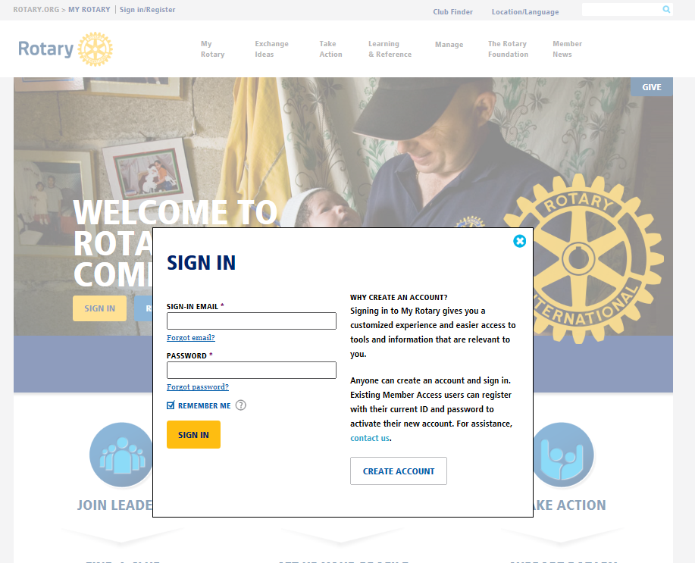
Step 3
Click on MANAGE then Rotary Club Central
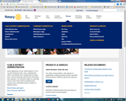

Step 4
Click on Foundation Giving to open
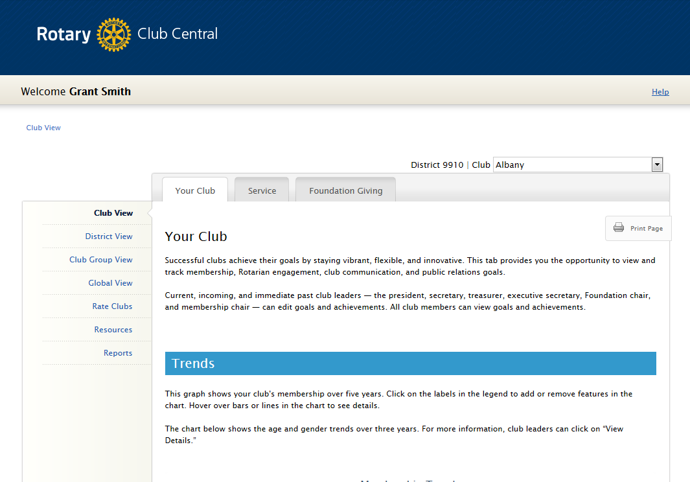
Step 5
Enter Goals using the EDIT BUTTONs. Then Save.
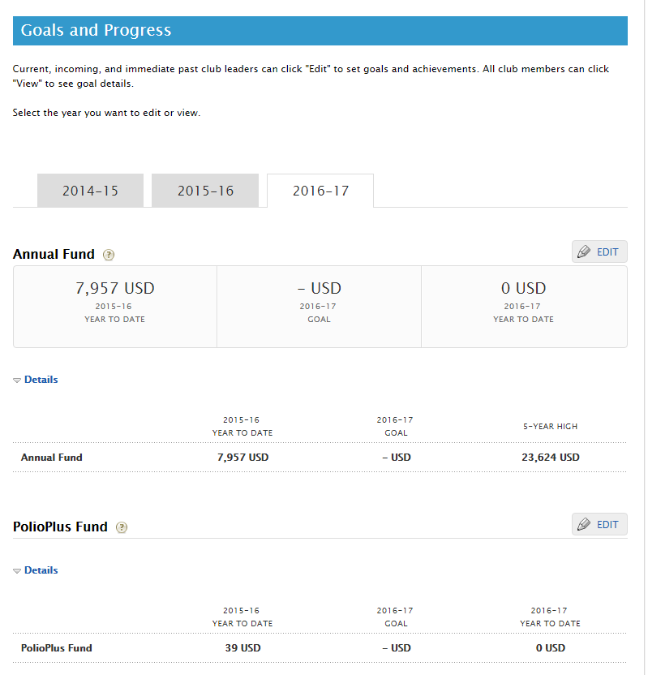
Step 6
To clarify, all planned contributions to “Annual Fund” are now not broken down. It is simply asking for your PLANED Contribution combining both Club and Personal.
In addition you should enter a Polio Plus Fund goal the same way, as a total of Club and Personal Contributions. NOTE TRF goal is US$1,500 per Club.
Then SAVE

