Finding your Club PHF Recognition Points
Step 1 Go to www.rotary.org to log in. Then click My Rotary.
Step 2
Click on yellow sign in box and the sign in screen appears. Log in using your e mail address. Create an account if you don’t already have one
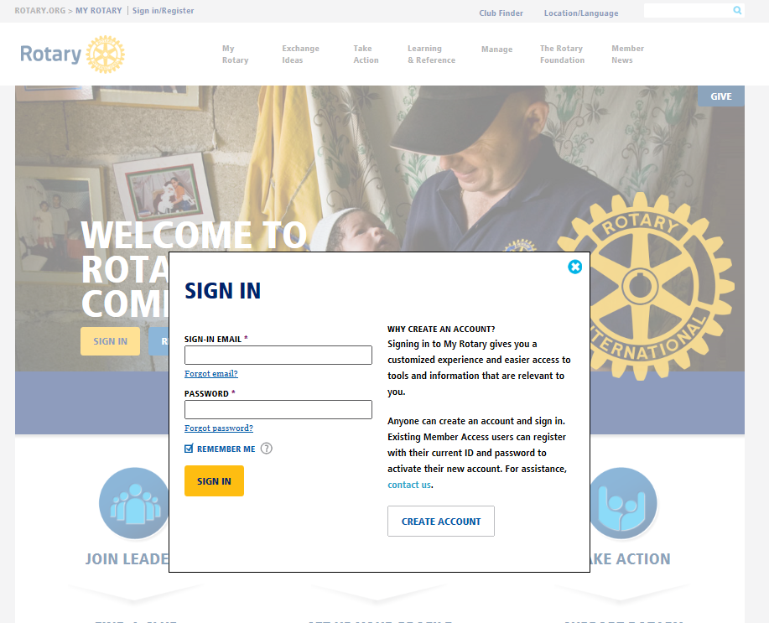
Step 3
Click on MANAGE then Rotary Club Central
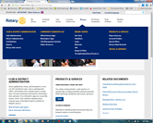

Step 4
Click on Foundation Giving to open
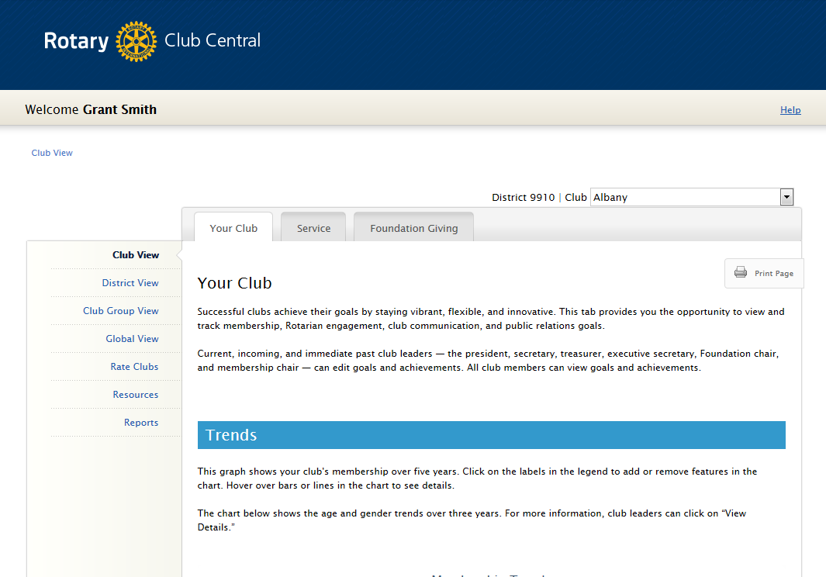
Step 5
Click on Reports. The reason you click on Foundation Giving first is that you will now be linked to reports about The Rotary Foundation.
Step 6
The screen below will open. Look under “Club Reports” and click on CLUB RECOGNITION SUMMARY.
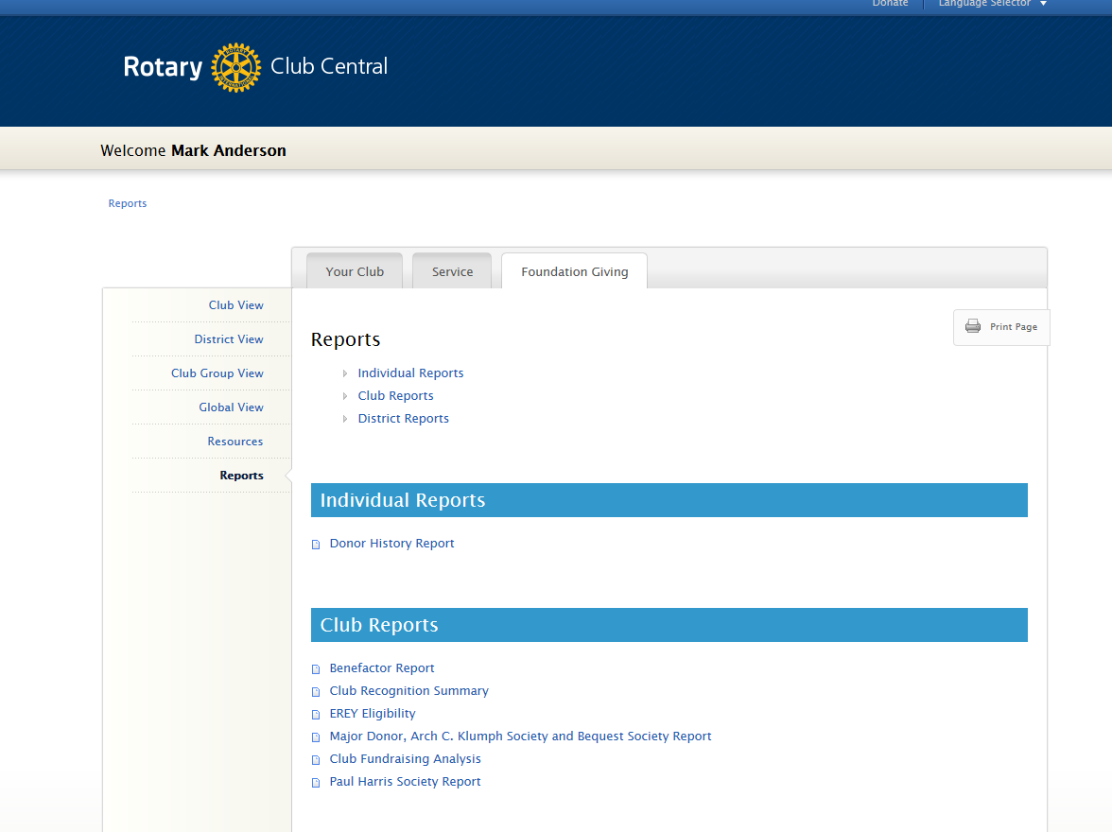
Step 7
The screen below will open with your report. The first line in this report show how many Foundation recognition points that you have available. You will need 1,000 points to affect a transfer. The points linked to the members are their points and CANNOT be transferred to the Club for Club use. These points can however be used with the member permission by the member forwarding a signed Recognition transfer request form.
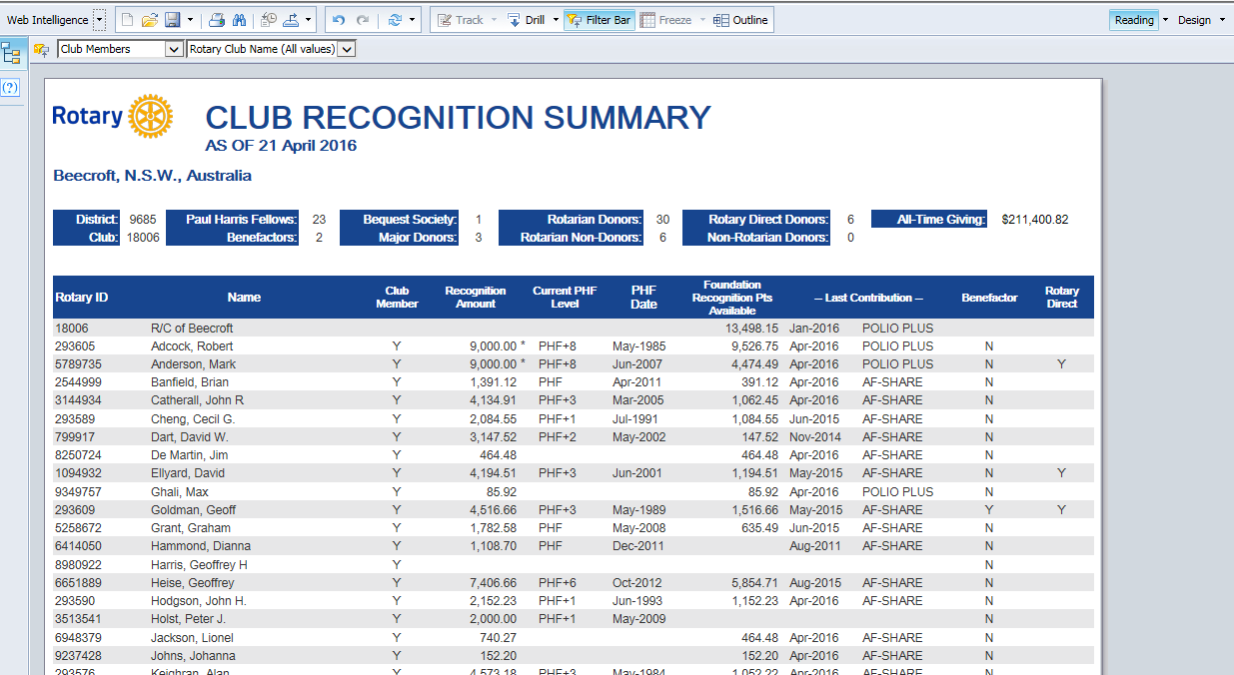
Step 8
History and non-member recognitions
In the top left corner of your screen there is a box that says “Club Members”
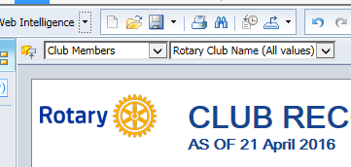
Click on the down arrow and highlight
“Members(All values)”
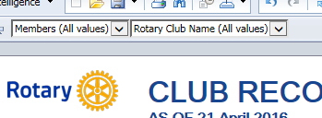
This will reset your report, to show every Paul Harris Fellow ever recognised by your Club. Prior to 1985 there may be some gaps in our data history and we do apologise for this.
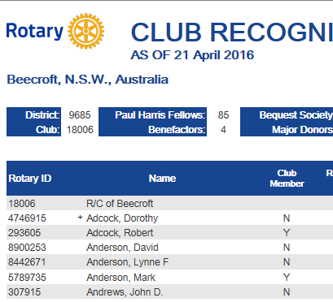
You now have a list of current members “Y”, past members and non-members “N”. You may even see an “H” indicating an honorary member.
With this column visible you have a complete history of who has been recognised with a Paul Harris Fellow. The history is fairly robust back to 1985. Prior to that there may be some gaps.
Step 9
Search www.rotary.org for the form below.
